

## Technical Coding Research Innovation, Navi Mumbai, Maharashtra, India-410206

Webseries Analytics

## A Case-Study Submitted for the requirement of

**Technical Coding Research Innovation**

## by

RudranshMishra

[TCRIB4R141]

Python.

**Internship program**: Data Science with Machine Learning and

**Date of Submission**: 02/12/23.

# INTRODUCTION

Machine Learning and Data Science with Python:

Machine learning and data science are two closely related fields that revolve around the analysis and interpretation of data to make informed decisions and predictions. Python has emerged as a powerhouse in these domains due to its versatility, extensive libraries, and a vibrant community of developers.

Here's a

concise introduction to each:

Machine Learning:

Machine learning is a subfield of artificial intelligence that focuses on developing algorithms and models that enable computers to learn from and make predictions or decisions based on data. It's like teaching computers to identify patterns

in data, and then use those patterns to make predictions or take actions. Machine learning encompasses a wide range of techniques, from traditional statistical methods to cutting-edge deep learning.

Data Science:

Data science is a multidisciplinary field that combines various techniques and methods to extract insights and knowledge from data. It involves collecting, cleaning, and organizing data, performing exploratory data analysis, and applying statistical and machine learning techniques to uncover valuable information. Data scientists often work with big data, extracting meaningful patterns and making data-driven decisions.

Python in Machine Learning and Data Science:

Python has become the de facto programming language for machine learning and data science due to several reasons. It offers a rich ecosystem of libraries such as NumPy, Pandas, Matplotlib, and Scikit-Learn, which streamline data manipulation, analysis, and modeling. Furthermore, Python's readability and ease of use make it accessible to both beginners and experienced professionals in these fields.

In summary, machine learning and data science are pivotal in today's data-driven world, and Python serves as the go-to tool for practitioners in these domains, offering the necessary tools and community support to tackle complex problems and extract valuable insights from data.

# OBJECTIVES

Python Objectives:

Python, as a versatile and powerful programming language, serves various objectives:

1. Simplicity and Readability: One of Python's primary objectives is to provide a clear and readable syntax. Its code is often described as almost like pseudocode, making it easy for developers to write and understand. This simplicity promotes rapid development and collaboration among programmers.
2. Extensibility and Libraries: Python offers a rich ecosystem of libraries and frameworks that cater to a wide range of applications. These libraries, including NumPy, Pandas, Matplotlib, and TensorFlow, facilitate tasks like data manipulation, scientific computing, data visualization, and machine learning. Python's extensibility allows developers to create custom modules and integrate with existing systems.
3. Cross-Platform Compatibility: Python is cross- platform, meaning code can run on various operating systems without modification. This portability is crucial for applications that need to be deployed on different environments, from web servers to scientific computing clusters. Python's versatility extends its reach across diverse domains, from web development to data analysis and automation.

Machine Learning Objectives:

1. Prediction and Automation: The primary goal of machine learning is to develop models that can predict future outcomes or automate decision-making processes. This is vital in various domains, including finance, healthcare, and manufacturing, where accurate predictions and automation can lead to significant improvements in efficiency and accuracy.
2. Pattern Recognition and Insights: Machine learning is designed to recognize patterns, trends, and relationships within data that might be challenging or impossible for humans to discern. This capability is

crucial for extracting valuable insights, such as customer preferences, market trends, or disease diagnosis from large datasets.

Optimization and Personalization: Machine learning enables optimization in various scenarios, like supply chain management, where it can help minimize costs and maximize efficiency. Additionally, it powers personalization in recommendation systems, tailoring content and products to individual preferences, enhancing user experience.

# Abstract

Methodology in machine learning and data science using JupyterLab involves a step-by step process of data analysis, model development, and experimentation, all within the JupyterLab environment. JupyterLab provides an interactive platform for combining code, data, and visualizations, making it a popular choice among data scientists and machine learning practitioners.

Here's a brief overview of the methodology:

* 1. Import Data:

In JupyterLab, you typically begin your data science or machine learning project by importing the dataset you intend to work with. Libraries like Pandas and Numpy are commonly used for this purpose.

Using Pandas, you can read data from various file formats, such as CSV, Excel, or SQL databases, into a DataFrame, which is a powerful data structure for handling tabular data.

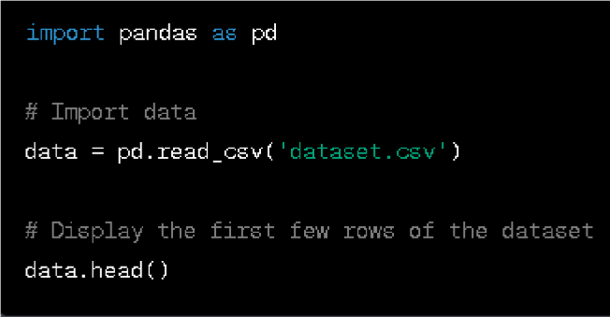

After importing the data, you can display a sample of it to get a quick overview of its structure by using the .head() method.

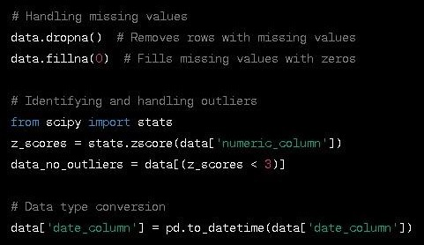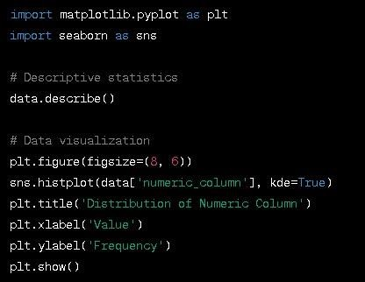

* 1. Data Exploration:

1. Data Cleaning:

Data can often be messy and require cleaning to ensure its quality. This step involves handling missing values, outliers, and formatting issues.

For missing data, you can use methods like .isnull() to identify missing values and .fillna() to replace them with appropriate values. Outliers, which are data points significantly different from the rest, can be identified through statistical methods and addressed by removal or transformation.

Data formatting issues may involve converting data types, standardizing date formats, or removing special characters.

To gain a deeper understanding of the dataset, you can perform data exploration, which involves using descriptive statistics and visualizations.

Descriptive statistics, such as mean, median, standard deviation, and quartiles, provide a summary of the data's central tendencies and spread.

Visualizations, created with libraries like Matplotlib and Seaborn, help you explore the data's distribution, relationships, and patterns. You can plot histograms, scatter plots, bar charts, and more.

#### as feature engineering and model development, by ensuring that your dataset is reliable and that you understand its characteristics and potential challenges.

* 1. Feature Engineering:1.Create New Features or Transform Existing Ones:

Feature engineering is the process of creating new features or transforming existing ones to enhance the performance of machine learning models. This can involve mathematical operations, aggregations, or extracting meaningful information from raw data.

For example, in a dataset containing timestamps, you might create new features like day of the week, time of day, or time elapsed since a particular event. These new features can provide valuable insights to the model.

* + 1. Normalize or Scale Features:

To ensure that all features have the same scale, it's often necessary to normalize or scale the data. Normalization typically scales the data to a range between 0 and 1, while scaling (standardization) gives features a mean of 0 and a standard deviation of 1.

This step is crucial because many machine learning algorithms are sensitive to the scale of the features. Normalizing or scaling features helps prevent certain features from dominating the learning process.

* + 1. Encode Categorical Variables:

Machine learning models typically require numerical inputs, but datasets often contain categorical variables (e.g., "red," "green," "blue" for colors). One-hot encoding is a common technique to convert categorical variables into a numerical format.

In one-hot encoding, each category is transformed into a binary vector, where each category corresponds to a unique binary position. This ensures that the model can understand and use categorical information without assuming ordinal relationships between categories.

Here's an example of how you might perform these feature engineering tasks in Python:

* 1. Model Development:

Select a machine learning algorithm (e.g., scikit-learn) based on the problem (classification, regression, clustering, etc.).Split the data into training and testing sets to assess model performance.Train the model using the training data.

1. Model Evaluation:

Evaluate the model using various metrics (accuracy, F1-score, RMSE, etc.). Utilize cross validation techniques to ensure robust model evaluation.

Adjust hyperparameters to optimize model performance.

1. Visualization and Interpretation: Visualize model results and insights, such as feature importance and decision boundaries.

Interpret model predictions and evaluate its impact on the problem.

1. Model Deployment:

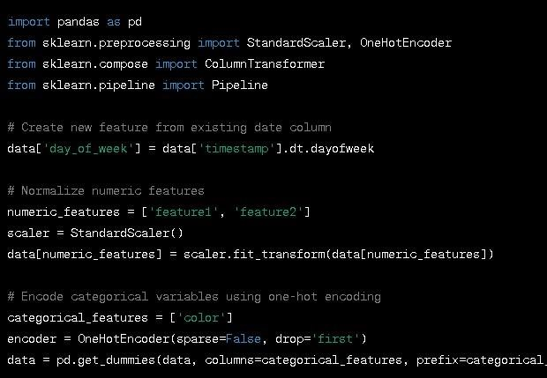If the model meets the desired performance, you can deploy it in a production environment. JupyterLab is not typically used for deployment but for development and experimentation.

1. Documentation and Reporting: Jupyter notebooks are great for creating interactive and informative reports that document the entire process. You can include code, visualizations, and explanations in a single document.

JupyterLab's strength lies in its interactive nature, allowing you to experiment with code, visualize data, and document your workflow seamlessly. It promotes a datadriven and iterative approach, where you can continually refine your analysis and models based on the results you obtain. It's an excellent tool for collaborative work, sharing insights, and creating reproducible research in the fields of machine learning and data science.

# EXPLORATORY DATA ANALYSIS:

Exploratory Data Analysis (EDA) is a crucial data

analysis technique that involves uncovering patterns, trends, and insights in raw data to inform further analysis and decision-making. It provides a foundational understanding of the dataset's characteristics, aiding in data preprocessing and

hypothesis generation. Box plots are excellent for comparing the distributions of multiple datasets and identifying outliers, while histograms provide a detailed view of the data's distribution, including its shape, skewness, and central tendency.

They both are plotted as shown in figure

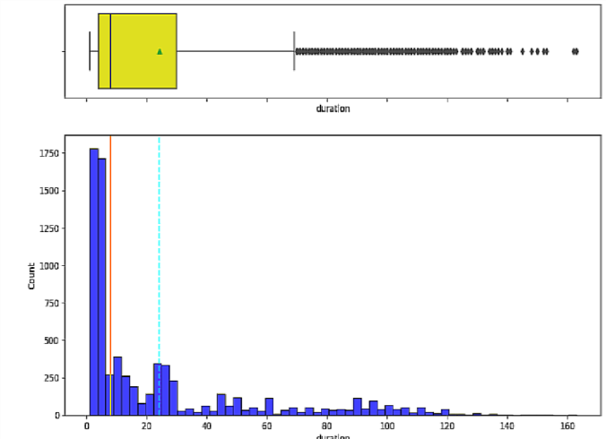

A correlation heatmap is a powerful visualization tool created using Python's data visualization libraries like Matplotlib or

Seaborn. It provides an insightful representation of how different variables in a dataset relate to each other. By displaying these relationships through colors, it helps us grasp the strength and direction of correlations. This, in turn, is immensely beneficial for various data-related tasks. In summary, a correlation heatmap is a visual gem in the toolkit of data professionals. It unveils the complex relationships within datasets with ease, aiding in various aspects of data analysis, from simplifying feature selection to optimizing model performance. It's a go-to tool in data preprocessing and exploratory data analysis, enabling data scientists to make informed decisions that lead to better results in subsequent analysis and modeling.

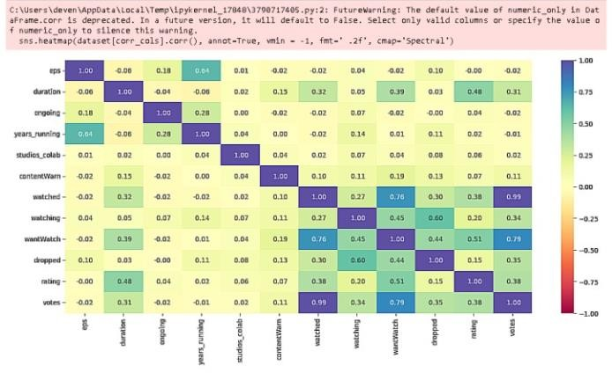

### MODEL BUILDING- REGRESSION:

Model building in regression analysis entails the selection and development of a mathematical equation that best represents the relationship between one or more independent variables and a dependent variable. The choice of the appropriate regression technique, whether it's linear, multiple, polynomial, or any other variant, hinges on the underlying assumptions and characteristics of the dataset. The process involves estimating the coefficients of the chosen regression equation using the available data, and subsequently, evaluating the model's goodness of fit and predictive performance.

Careful consideration of model assumptions, data transformations, and the interpretation of coefficient estimates are crucial in building a robust regression model that can effectively explain and predict the relationships within the data. Here Linear Regression is used. It provides understanding of the relationships between various factors influencing viewer behavior and engagement with web series content. By employing this methodology, we can model and quantify the impact of different independent variables, such as content duration, release schedule, and marketing expenditure, on

critical performance metrics like viewership counts and audience retention rates. Through this research, we aim to showcase how linear regression, in conjunction with other data science techniques, can unlock actionable insights that empower content creators and producers in making data- informed decisions.

### FEATURE SELECTION:

Feature selection is a strategic process to identify the most relevant and influential factors affecting web

series viewership and engagement. By carefully curating a subset of informative features from the myriad of available data, we not only reduce dimensionality but also enhance model performance, interpretability, and computational efficiency. Here we have used Sequential Search. SEQUENTIAL SEARCH FEATURE SELECTION: Sequential

search feature selection is a powerful technique within the realm of Web Series Analytics, designed to optimize the predictive modeling process. In this research paper, we delve into the application of sequential search methods, to identify the most influential features among the vast array of variables in web series data. By systematically adding or removing variables and evaluating model performance at each step, sequential search methods help us pinpoint the subset of features that maximize prediction accuracy while minimizing computational complexity. Through practical experiments and real-world case studies, we illustrate how sequential search feature selection enhances the efficiency and interpretability of predictive models, providing valuable insights for content creators, producers, and stakeholders in the digital entertainment industry.

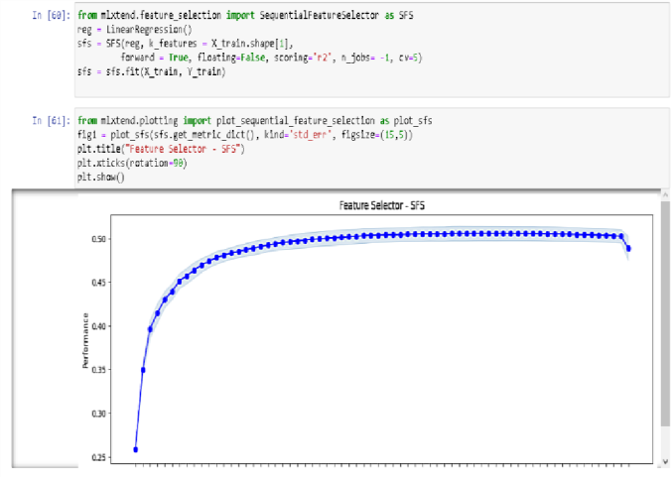

### ACKNOWLEDGMENT:

We would like to express my sincere gratitude to all those who have contributed to the successful completion of this research paper on Web Series Analytics. Firstly, we would like to thank our mentors and advisors for their invaluable guidance, support, and expertise throughout the research process. Their insights and encouragement have been instrumental in shaping the direction of this work. We would also like to extend our thanks to my colleagues and peers for their valuable discussions and feedback, which enriched the quality of this paper. Additionally, we are grateful to the academic and research community for their contributions to the field of data science and machine learning, providing the foundation upon which this research was built. Lastly, we want to acknowledge the continuous advancements in technology and the availability of opensource tools and datasets, which have made this research possible.

**CONCLUSION:** In summary, our research in Web Series Analytics emphasizes the pivotal role of data- driven methodologies, particularly through linear regression models, in unraveling the intricacies of viewer behavior and engagement. Through the application of these models, we've unveiled profound insights into the intricate relationships between various factors and key performance metrics for web series. These insights have the potential to revolutionize the strategies employed by content creators and producers, offering them data-backed guidance for content creation, scheduling, and enhancing audience engagement.

As the digital entertainment landscape continues to evolve and become increasingly competitive, the integration of data science techniques stands as a cornerstone for innovation and success in the industry. Our research findings underscore the importance of continuous exploration and the untapped potential of data-driven decision-making in shaping the future of web series and the broader domain of digital entertainment. This journey is an ongoing one, where data will continue to be the compass guiding creators and industry stakeholders towards more engaging and successful content offerings.

Our findings underscore not only the current significance but also the promising future of data- driven decision-making. By harnessing the power of data, the web series and digital entertainment industry can adapt and thrive in an era where viewers' preferences and behaviors are constantly evolving. Our research reinforces the importance of ongoing exploration and the assurance that data driven insights will play a pivotal role in shaping the future of web series and digital entertainment, ensuring they remain relevant and engaging to audiences worldwide.